**ACKNOWLEDGEMENT**

We are highly thankful and indebted to Dayalbagh Educational Institute and technical staff for providing us vital and valuable information about the different facts of virtual power labs and their respective departments thus helping us to gain an overall idea about the experiments of virtual power lab.

We express our gratitude to Dr. Devendra Kumar Chaturvedi Sir for giving us a chance to feel the lab environment and for helping us in every possible way.

We would like to thank other faculty members who have been a constant source of encouragement & inspiration during our studies & have always provided us support for the completion of our project.

**INTRODUCTION TO VIRTUAL LAB**

Virtual Labs is a project initiated by the [Ministry of Human Resource Development](https://en.wikipedia.org/wiki/Ministry_of_Human_Resource_Development), [Government of India](https://en.wikipedia.org/wiki/Government_of_India), under the National Mission on Education through Information and Communication Technology. The project aims to provide remote-access to Laboratories in various disciplines of science and engineering for students at all levels from under-graduate to research.

It also intends to develop a complete Learning Management System where the students can avail the various tools for learning, including additional web-resources, video-lectures, animated demonstrations and self-evaluation. There is also a component wherein costly equipment and resources are shared, which is otherwise available to only a limited number of users due to constraints on time and [geographical distances](https://en.wikipedia.org/wiki/Geographical_distance).

**VIRTUAL POWER LABS**

Physical distances and the lack of resources make us unable to perform experiments, especially when they involve sophisticated instruments. Also, good teachers are always a scarce resource.

Electrical machines and power system are the back bone of electrical engineering and play a vital role in industry. It is therefore essential that students of Electrical Engineering should have a proper background in these areas.   
It is observed that the students do not take much interest in the laboratory. Hence, the necessity is felt to explain the concepts of electrical machines with suitable programs besides the theory and practice. This will provide better understanding of the subject.

Goal of the Virtual Power Lab

To develop virtual machines and power laboratory to facilitate the students to work with their own convenience and easily understand the practical concepts. Also it helps in generating the interest in students' community to get better insight about the subjects related to machines and power systems.

Lab work is very important to bridge the gap between the theoretical knowledge and practical work. The motto of the laboratory work is to learn here and earn outside.

Students always have fear while working experimentally in the laboratories. Especially in electrical engineering labs like machines lab where the voltage level is generally 230 V or 415 V at 50 Hz, which may cause a serious shock or sometimes cause death also. Hence, there is a need to follow certain precautions to work safely in the lab. While working in lab, one must properly be isolated from ground (i.e. wear proper shoes), so that there is no chance of flowing the leakage current through the body.

***OBJECTIVE*:** To study the differential Protection of Power/Distribution transformer.

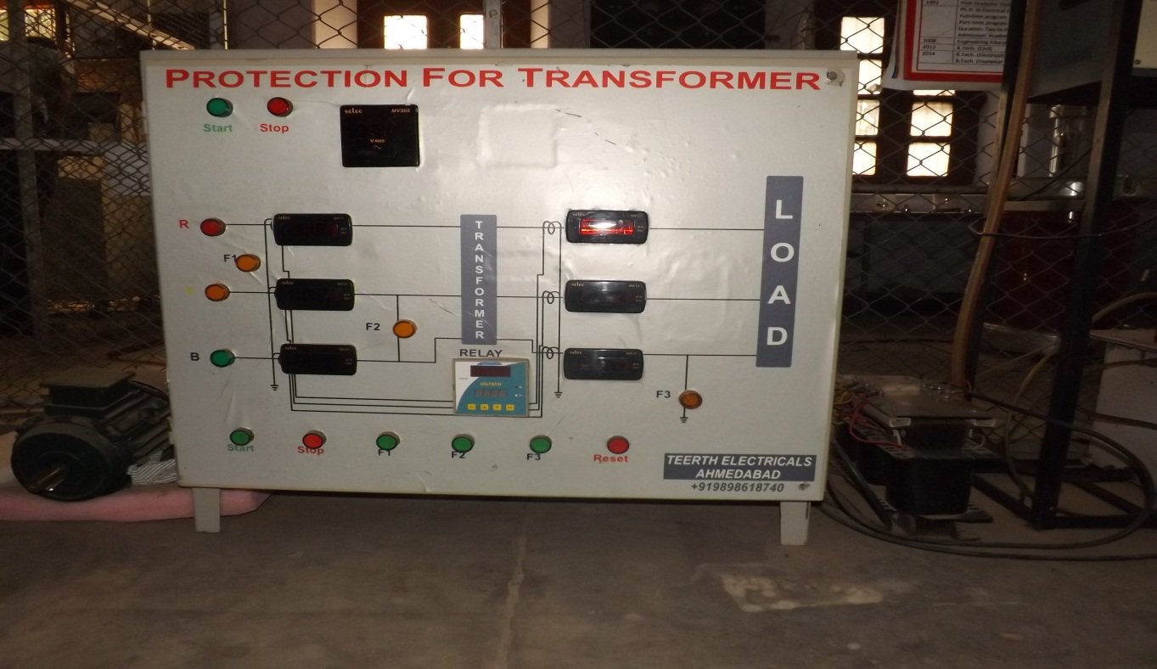***EQUIPMENT REQUIRED*:**

* + - Main Transformer
    - Current Transformers
    - Differential Relay

***LINE DIAGRAM:***

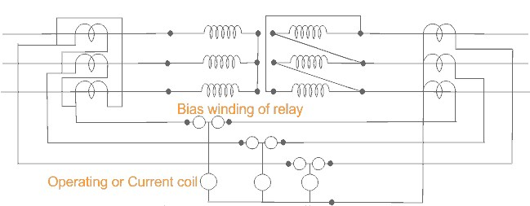

Schematic diagram for differential protection of three phase transformer.

***THEORY*:**

A transformer is a static device totally enclosed and generally oil-immersed. Thus, chances of fault occurrence on them are rare. However, consequences even so, could be very serious unless the transformer is quickly disconnected from the system.

Power transformers are classified as one of the most valuable equipment in a power system, hence their protection is of very high importance. The transformer differential protection provides fast tripping in case of a fault - before severe damage spreads out. Such faults are:

* short circuits between turns, windings and cables inside the transformer housing
* earth faults inside the housing
* Short circuits and earth faults outside the housing but within the protected zone (e.g. at bushings or supply lines).

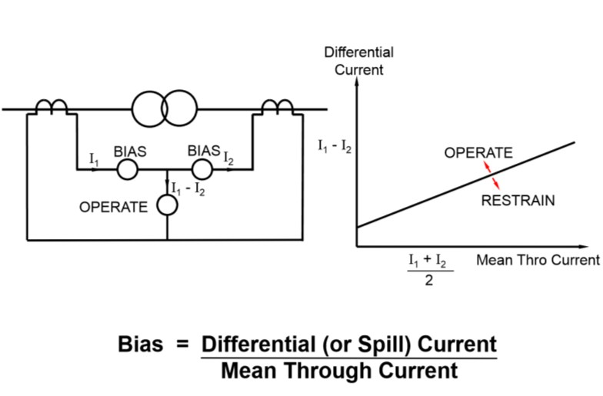

Diagram of Biased Differential Protection

A differential relay is one that operates when the phase difference between the two or more similar electrical quantities exceeds a pre-determined value.

***WORKING AND OBSERVATION*:**

The differential relay is one that compares the current entering a section of the system with that leaving the section. Under normal operating conditions or external fault (fault falling out-of-zone) the two currents are equal but as soon as some internal fault occurred this condition of equality of the two current ceased to be true. Then, the difference b/w the incoming and outgoing current is arranged to flow through the operating coil of the relays. If this differential current is equal to or greater than the pickup valve the relay will operate and open the circuit breaker to isolate the fault-section. The different problems in differential protection of transformer are:

* Current Mismatch Caused by the Transformation Ratio
* Due to possible mismatch of ratios among different current transformers.
* DeltaWye Transformation of Currents
* •Zero Sequence Elimination
* Phase differences between primary and secondary side, caused by transformer vector groups, have to be duly considered.
* Switching operations in the grid have to be recognized as such.
* Inrush currents of the transformer must not result in maloperation.

Connection of interposing C.T.s is dependent on the vector group of the power transformer. For instance, for transformers with star (Y) windings the interposing C.T.s are connected in delta (Δ) to reject residual currents (i.e. currents flowing to the transformer due to an earth fault outside the protected zone and which would produce a differential current Id) and to prevent mal-operation of the differential protection.

**Transformer inrush**

When a transformer is first energized, a transient in- rush current flows. This inrush current occurs only in the energized winding and has no equivalent on the other side of the transformer. The full amount of inrush current appears as differential current and would cause the differential relay to trip if there is no stabilization against the inrush phenomenon.

Typically the inrush current contains three components that distinguish it from other fault currents:

1. The DC-component: The DC-component is present at least in one phase of the inrush current, depending on the instant of energizing.
2. The second harmonic: The second harmonic is present in all inrush currents due to uni-directional flux in the transformer core.
3. The fifth harmonic: The fifth harmonic is present when the transformer is subjected to a temporary overvoltage.

***OBJECTIVE:***To study protection of Induction Motor using numerical relay.

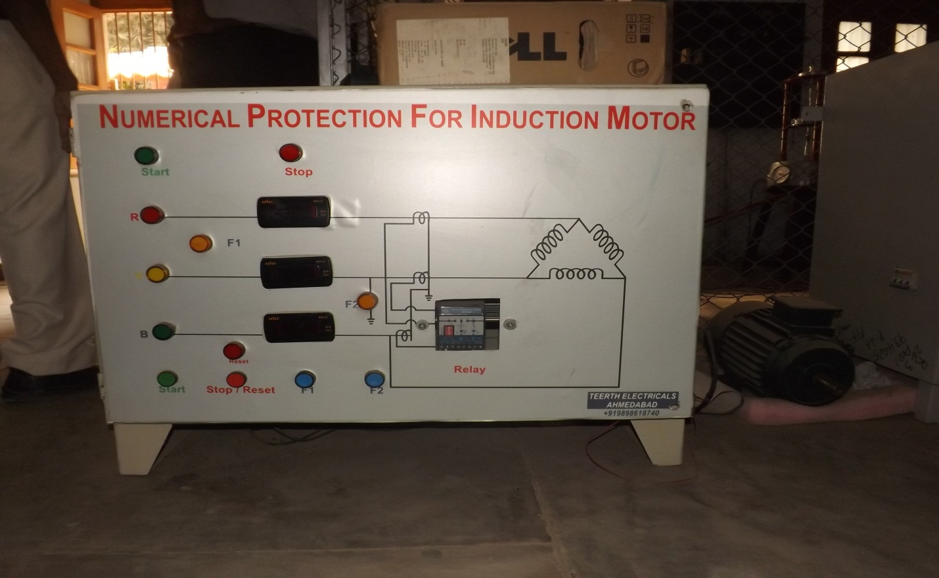

***EQUIPMENT REQUIRED:***

* Three phase induction motor
* CTs
* Numerical relay

**Circuit Diagram**

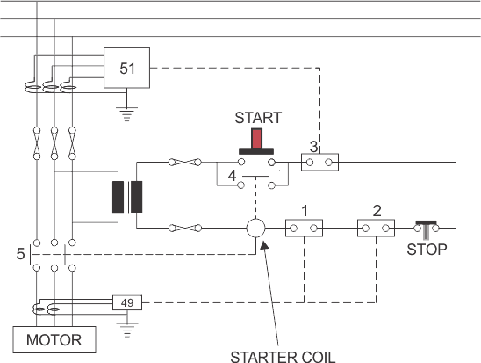

***THEORY:***

Thethree phase induction motors are very reliable and robust, modern designs operate much closer to the limits of thermal margins and to give adequate protection, sophisticated protective relays are required. In addition, increased industrial use of power electronics leads to incorporate different harmonics in the system, which adversely affect the induction motor performance and cause considerable rotor heating.

The numerical relay has been designed to protect the motor against these phenomena as well as known abuses such as mechanical overload , stalling and locked rotor, sort circuit , earth fault , phase unbalancing , single phasing , terminal box and cabling failures , and too frequent starts .

The term singlephasing means one of thephase is open. Tis condition subjects the motor to the worst case of voltage unbalance. Thephase current will increase by √3 times. Noting can prevent or eliminate single phasing.

A numerical relay is a solid state relay also called static relay. It contains electronic circuitry which may include transistors, ICs, diode and other electronic components. There is a comparator circuit in it, which comparing 2 or more voltages or currents gives output applied to either a slave relay or a thyristor circuit.

The slave relay is an electromagnetic, semi static relay which closes its contacts .The numerical relay as low burden on CT, PT, fast operation, absence of mechanical inertia and contact trouble,long life and less maintenance. So, they are superior to electromagnetic relay, but they are costly and required more maintenance.

***WORKING AND OBSERVATION:***

There are mainly two types of faults on Induction Motor.

1. **Winding – Winding fault:**

This mainly occurs due to insulation failure of stator winding. This type of fault results in imbalance current between two phases. This imbalance current is then served by numerical relay to cause the trip of supply.

1. **Winding – Earth fault:**

When a winding is earthed due to some reasons like insulation failure, ten voltage drop is very fast but current increases. This is a dangerous situation and this imbalance is sensed by the numeric relay which trips the supply of motor.

***RELAY DETAILS:***

The Motor Protection Relay (MPR30) is a tree phase LT motor protection relay for motor sizes up to 50KW (max. 88A current). It is a low cost solution, offering five major protections for motors widely used in fans, pumps, crushers, mills, compressors, belt conveyers, centrifuges, mixers, ventilators, escalators, motorized valves etc. Major advantage is that it provides E/F coordination in contactor-started motors, thus offering greater security, operator safety and economy. The relay is micro-controller based, highly user friendly and compact with inbuilt CTs. The relay can also be used for protection of larger motors by using external CTs.

SOME BASICS ABOUT HTML USED FOR SIMULATION

**Hypertext Markup Language** (**HTML**) is the standard [markup language](https://en.wikipedia.org/wiki/Markup_language) for creating [web pages](https://en.wikipedia.org/wiki/Web_page) and [web applications](https://en.wikipedia.org/wiki/Web_application). With [Cascading Style Sheets](https://en.wikipedia.org/wiki/Cascading_Style_Sheets) (CSS) and [JavaScript](https://en.wikipedia.org/wiki/JavaScript) it forms a triad of cornerstone technologies for the [World Wide Web](https://en.wikipedia.org/wiki/World_Wide_Web). [Web browsers](https://en.wikipedia.org/wiki/Web_browser) receive HTML documents from a [web server](https://en.wikipedia.org/wiki/Webserver) or from local storage and render them into multimedia web pages. HTML describes the structure of a web page [semantically](https://en.wikipedia.org/wiki/Semantic) and originally included cues for the appearance of the document.

[HTML elements](https://en.wikipedia.org/wiki/HTML_element) are the building blocks of HTML pages. With HTML constructs, [images](https://en.wikipedia.org/wiki/Img_(HTML_element)) and other objects, such as interactive may be embedded into the rendered page. It provides a means to create [structured documents](https://en.wikipedia.org/wiki/Structured_document) by denoting structural [semantics](https://en.wikipedia.org/wiki/Semantics) for text such as headings, paragraphs, lists, [links](https://en.wikipedia.org/wiki/Hyperlink), quotes and other items. HTML elements are delineated by *tags*, written using [angle brackets](https://en.wikipedia.org/wiki/Bracket#Angle_brackets). Tags such as <img /> and <input /> introduce content into the page directly. Others such as <p>...</p> surround and provide information about document text and may include other tags as sub-elements. Browsers do not display the HTML tags, but use them to interpret the content of the page.

HTML can embed programs written in a [scripting language](https://en.wikipedia.org/wiki/Scripting_language) such as [JavaScript](https://en.wikipedia.org/wiki/JavaScript) which affect the behavior and content of web pages. Inclusion of CSS defines the look and layout of content. The [World Wide Web Consortium](https://en.wikipedia.org/wiki/World_Wide_Web_Consortium) (W3C), maintainer of both the HTML and the CSS standards, has encouraged the use of CSS over explicit presentational HTML since 1997.